Exploratory Data Analysis of Indian

Rainfall Data

India is an agricultural country and secondary agro based market will be steady with a good monsoon. Theeconomic growth of each year depends on the amountof duration of monsoon rain, bad monsoon can lead todestruction of some crops, which may result in scarcityof some agricultural products which in turn can cause food inflation, insecurity and public unrest. In our analysis we are trying to understand the behavior of rainfall in India over the years, by months and different

# Describing the data:

Data-set is downloaded from “data.gov.in” website. It has data for 117 years (1901– 2017) consisting of monthly and seasonal data for all 36 meteorological subdivisions of India. So in total we have 117*12*36 = 50,544 observations. Our data-set had 0.7% of missing values. For the subdivision Arunachal Pradesh we had missing values for the first 15 years i.e. 1901 to 1915, sofor all subdivisions we have considered data from 1916 to 2017when we are analyzing as whole India. For the rest of the missing values we have used sequential imputation technique.

Below table shows mean rainfall observed for each month overyears. We can see that average rainfall is high in July and Augustfollowed by June and September.

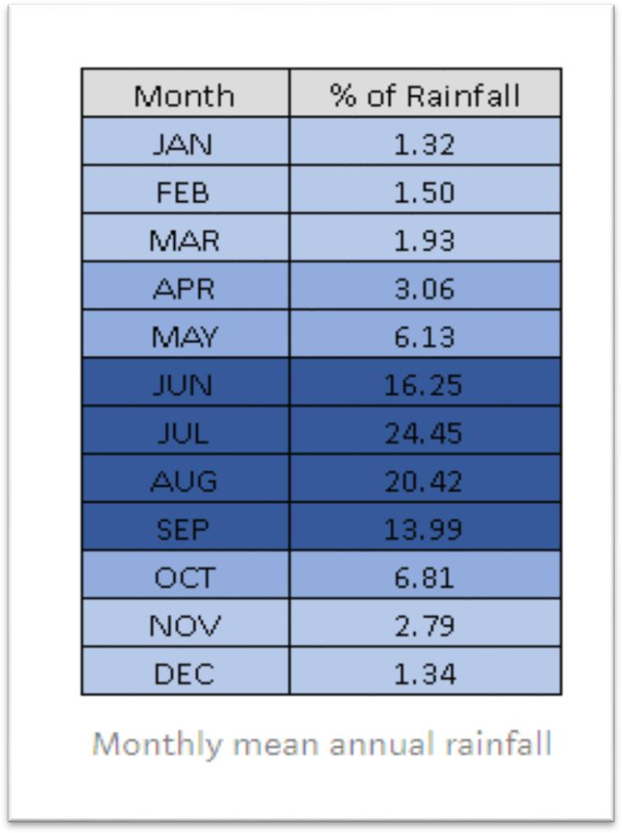

# Annual rainfall by months:

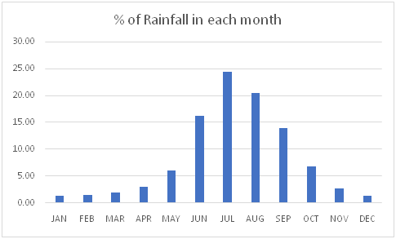

The below graph shows the percentage of rainfall each month receives when

we consider India as a whole. The rainfall in the months of June, July, August and September together contribute to almost 80% of the annual rainfall.

# Annual rainfall by subdivision

The following is a heat map plotted based on sum ofrainfall received by each subdivision for all these years. The subdivisions with large area represents high rainfall and with small boxes represent less rainfall. We can see that the subdivision located at Southwest and Northeast part of India have receivedmore rainfall compared to central India.

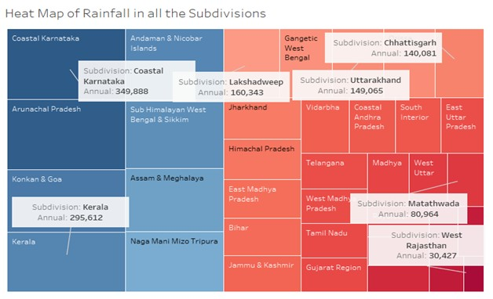

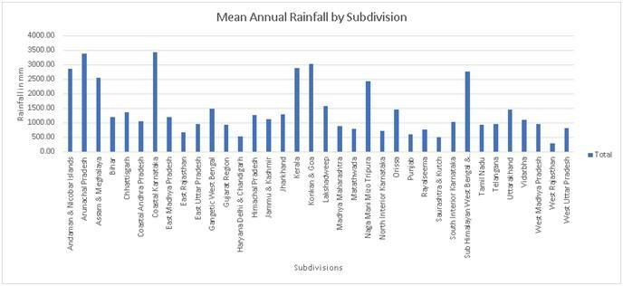

The average rainfall and variation values are plotted for each subdivision on different graphs which are given below. We can see that the subdivision which receive High rainfall have less variation seen over years whereas the subdivisions receiving low rainfall showed more variation over the years.

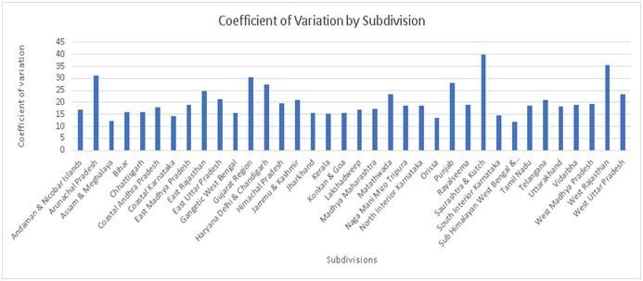

# Understanding the Monsoon in India:

We will now move to a more interesting part of the analysis.

We will see what exactly is monsoon, different types of monsoon winds in India, which

subdivisions of India receivesrainfall from which monsoon winds and why only particular subdivisions receive highest rainfall during this monsoonseason.

Before addressing these questions, we will see the basic concept of how rainfall actually occurs. So basically, during the summers, the Indian subcontinent heats up more as compared to the Indian ocean as the sun is directly over thelandmass. This creates a low pressure over the Indian subcontinent and a relatively low pressure over the Indian ocean. And as we know, the wind flows from high pressure area to the low pressure are in order to fill the void that was created thanks to the pressure system. So when the wind starts flowing from high pressure area to low pressureare i.e. from sea to land, it picks up the moisture from the sea and while entering the indian subcontinent it comes incontact with the high terrains and hence precipitation occurs.

Now that we have understood how rainfall occurs we will now see what exactly is monsoon?Monsoon is traditionallydefined as a seasonal reversal of wind accompanied by corresponding changes in precipitation.

As seen in the image below, India receives rainfall fromSouthwest Monsoon winds (Summer Monsoon or AdvancingMonsoon) and Northeast Monsoon winds (Winter Monsoon or Retreating Monsoon)

The Southwest Monsoon usually starts in the first week of June and ends by first week of September and monsoon usually starts retreating from the Indian Subcontinent by the start of September and leaves the subcontinent completely by the end of November. And as we have seen in the previous graphs that Southwest monsoon providesalmost 80% of the rainfall in India. This Southwest Monsoon has two branches, namely Arabian Sea branch and

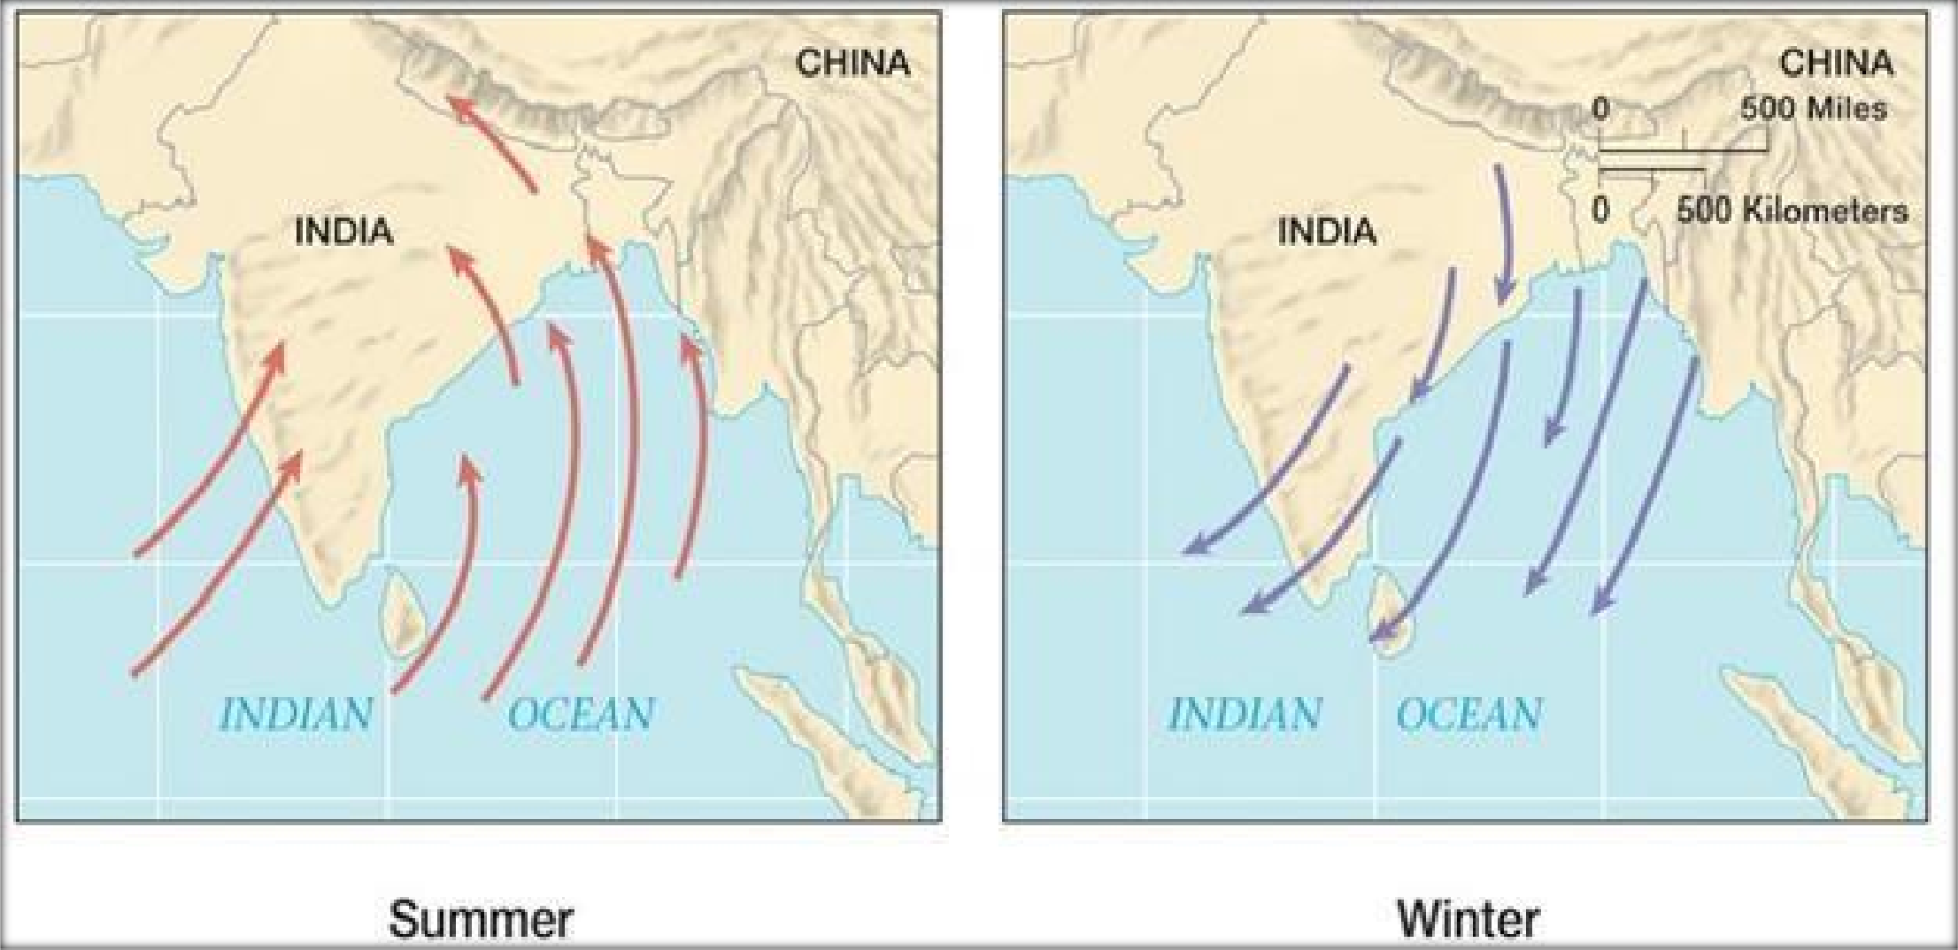

The following figure shows the cycle of

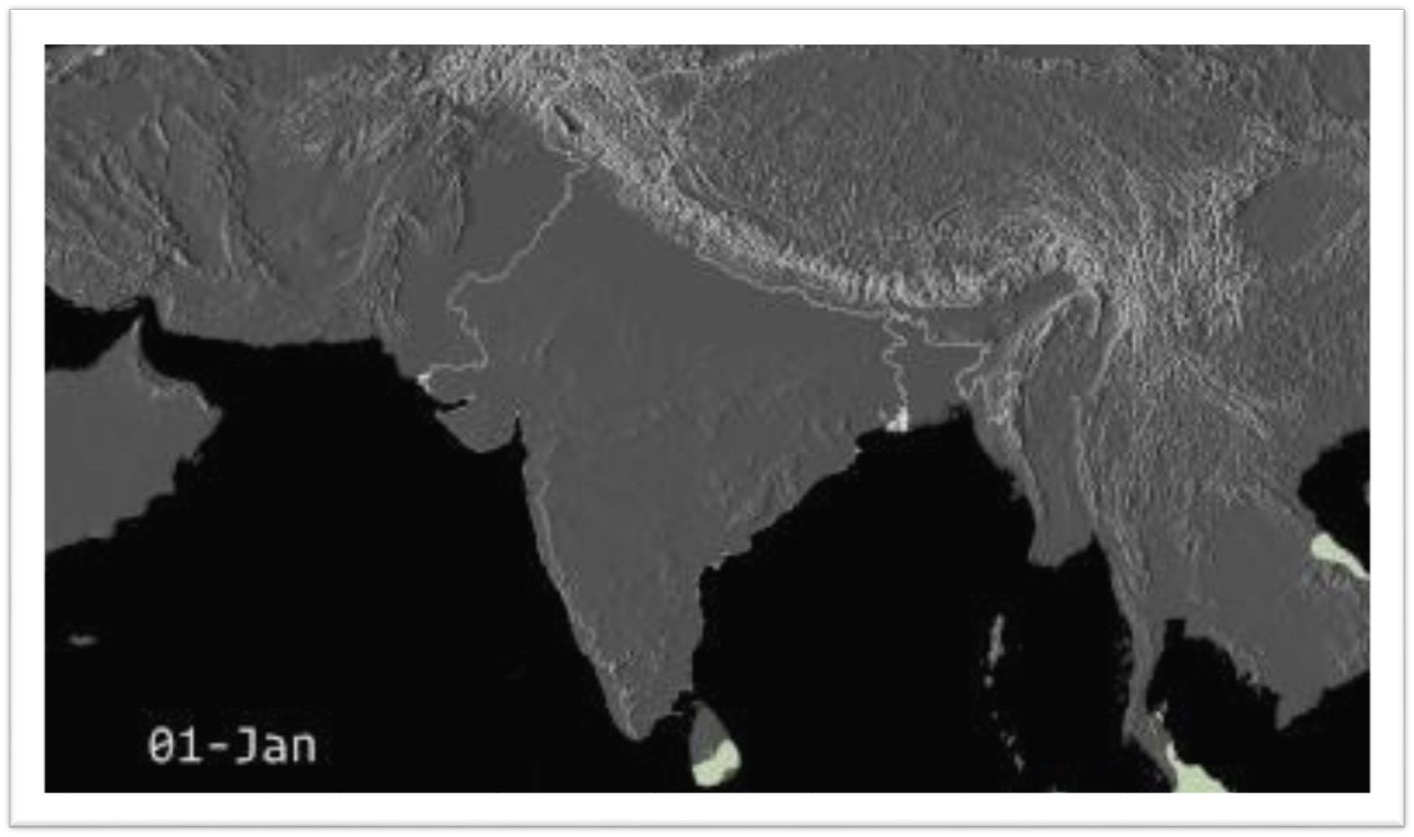

monsoon in India over a year

Now, due to the presence of high rising Western

Ghats which runs along the South West coast of India in the states of Kerala, Karnataka, Goa and Maharashtra, they block the Arabian Sea branch of southwest monsoon and hence these regions receive very high rainfall during monsoon season.This is shown in the graph below. (For all the graphs we have considered the last 3 decades i.e.last 30 years data (1987–2017))

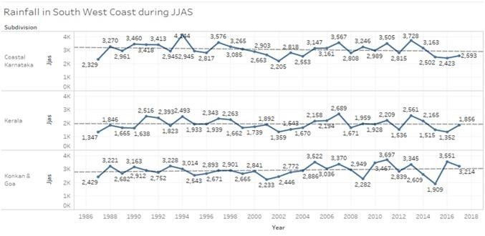

The Bay of Bengal branch of the Southwest

Monsoon provides rainfall to the eastern and northeastern regions of India. Due to the presence of theeastern ghats along Orissa and West Bengal, these regions receive high rainfall in the East and when this branch reaches the north eatsern part of India

i.e. Sikkim, Arunachal Pradesh, Assam & Meghalaya,due to the presence of Khasi hills and other hilly areas, these subdivisions receive very high rainfall. Cherrapunji in Meghalaya is titled as one of the wettest places on earth.

The average annual rainfall in these regions is

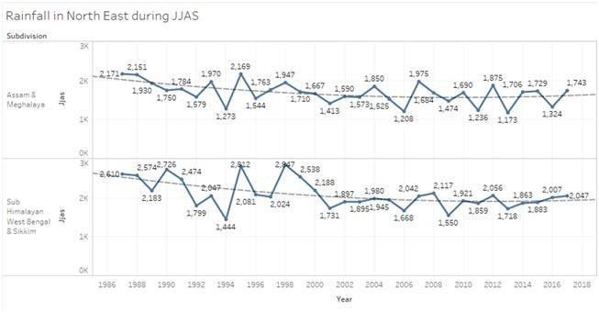

shown in the graphs below.

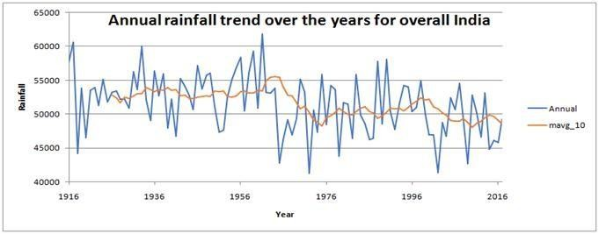

# Annual Rainfall trend over the years for whole India

10 years moving average was plotted, we can

see that there is a decreasing trend in rainfall in the recent years.

# Rainfall Data Analysis for Subdivision TamilNadu

To do rainfall data analysis of Tamil Nadu subdivision,we have considered the data from year 1901 to 2017. First we will see the distribution of rainfall overmonths and we can see in below figure that rainfall ismore in October and November compared to other months as Tamilnadu receives rain during retreating monsoon season because of Northeast trade winds.

The climate of Tamil Nadu is tropical in nature with less variation in temperature in summer and winter.This is because of its geographical location.

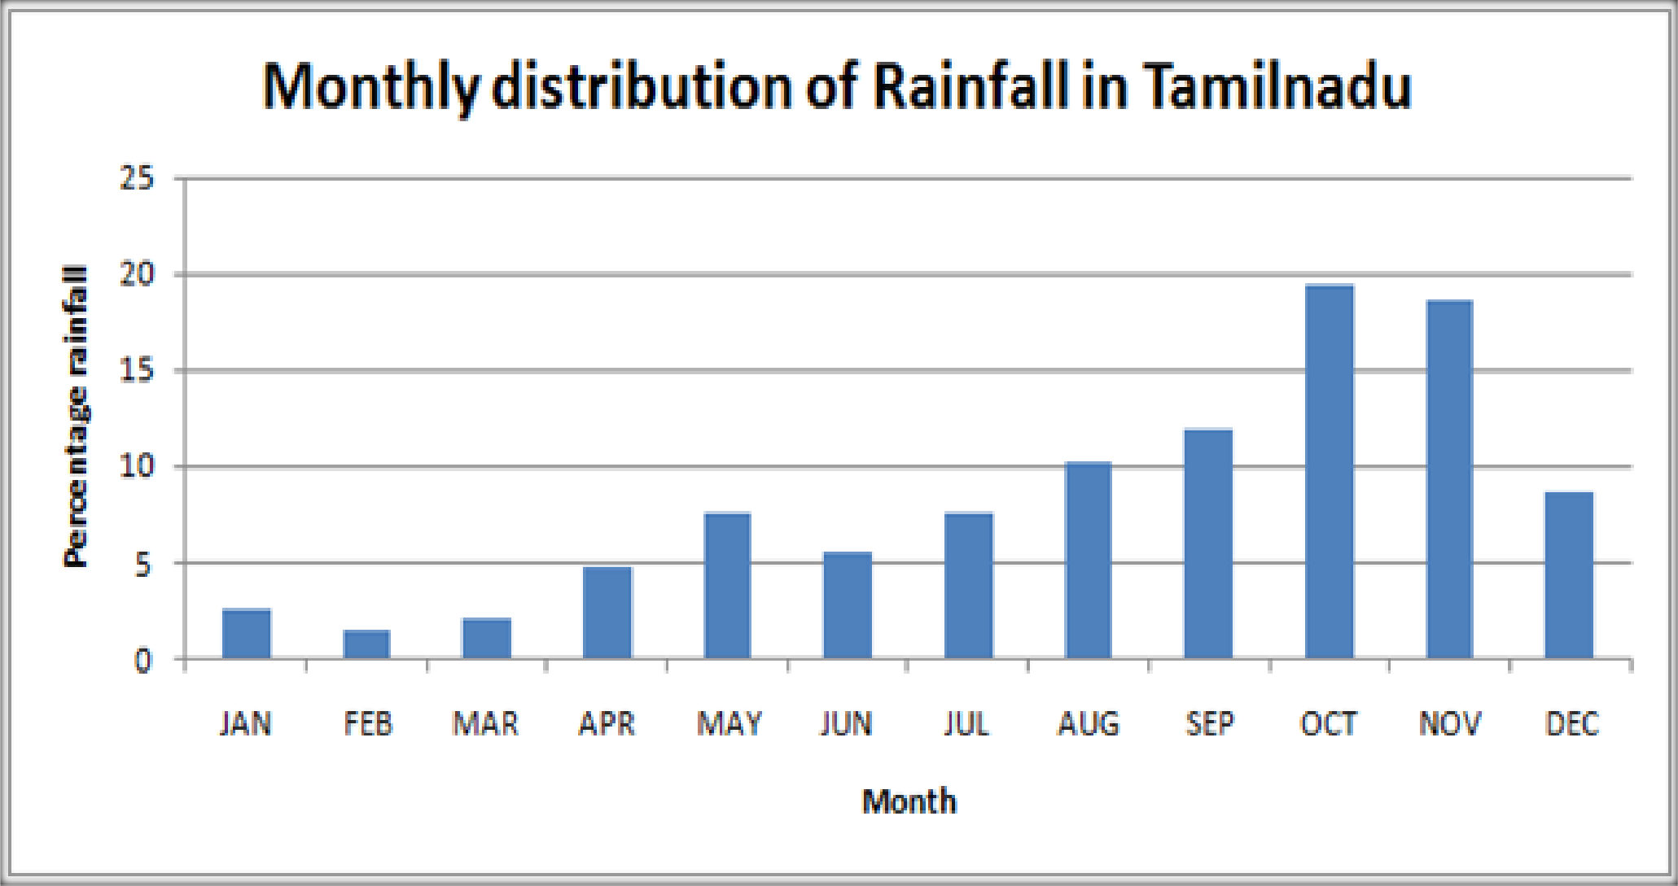

# Rainfall Data Analysis for Subdivision TamilNadu

To do rainfall data analysis of Tamil Nadu subdivision, we have considered the data from year1901 to 2017. First we will see the distribution of rainfall over months and we can see in below figure that rainfall is more in October and November compared to other months as Tamilnadu receives rain during retreating monsoon season because of Northeast trade winds. The climate of Tamil Nadu istropical in nature with less variation in temperaturein summer and winter. This is because of its geographical location.

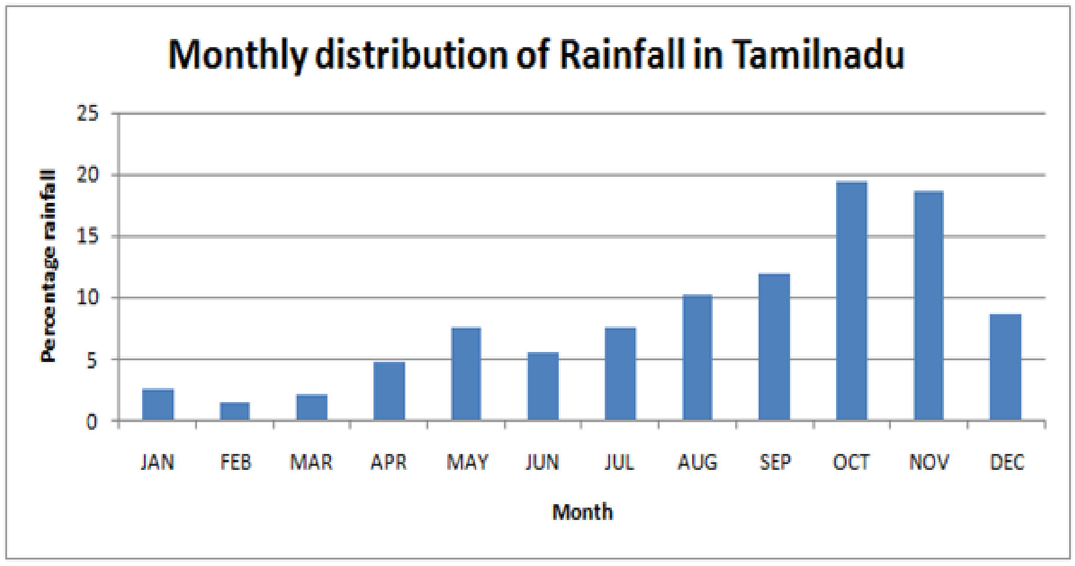

The below graph shows rainfall in Tamil Nadu in months October and November here we can see that most of the years when there is very low rainfall in October there is very high rainfall in November and vice versa. Tamil Nadu also rainfallsfrom tropical cyclones emerging in the neighborhood of Andaman islands during the retreat monsoon.

In 2015 there were south Indian floods, the flooding in Chennai was described as the worst in acentury. In winters of 2017 the worst drought in a century happened in southern India.

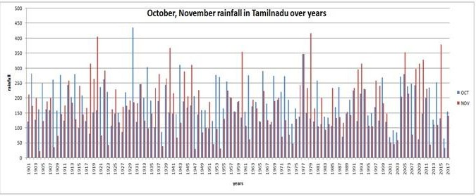

**import** numpy **as** np *# linear algebra*

**import** pandas **as** pd *# data processing, CSV file I/O (e.g. pd.read_csv)*

**import** matplotlib. Pyp lot **as** plt

**import** seaborn **as** sns

**import** random

*# Input data files are available in the "../input/" directory.*

*# For example, running this (by clicking run or pressing Shift+Enter) will list all files under the input directory*

**import** os

**for** dirname, _, filenames **in** os**.** walk('/kaggle/input'):

**for** filename **in** filenames:

print(os **.**path**.** join(dirname, filename))

In [7]:

data **=** pd**.** read csv('/content/rainfall_India_2017 (1).csv')**.**rename(columns**=**str**.** lower)

data**.** head(3)

Out[7]:

|  |  |  |  |  |  |  |  |  |  |  |  |  |  |  |  |
| --- | --- | --- | --- | --- | --- | --- | --- | --- | --- | --- | --- | --- | --- | --- | --- |
| SI NO | subdivisi on | year | jan | feb | mar | apr | may | jun | jly | aug | sep | oct | nov | dec | annual |
| 0 | Andaman & Nicobar Islands | 1901 | 49.2 | 87.1 | 29.2 | 2.3 | 528.8 | 517.5 | 365.1 | 481.1 | 332.6 | 388.5 | 558.2 | 33.6 | 3373.2 |
| 1 | Andaman & Nicobar Islands | 1902 | 0.0 | 159.8 | 12.2 | 0.0 | 446.1 | 537.1 | 228.9 | 753.7 | 666.2 | 197.2 | 359.0 | 160.5 | 3520.7 |
| 2 | Andaman & Nicobar Islands | 1903 | 12.7 | 144.0 | 0.0 | 1.0 | 235.1 | 479.9 | 728.4 | 326.7 | 339.0 | 181.2 | 284.4 | 225.0 | 2957.4 |

data**.**info()

RangeIndex: 4188 entries, 0 to 4187

|  |  |  |  |  |
| --- | --- | --- | --- | --- |
| Data | columns (total 15 columns): | | |  |
| # | Column Non-Null Count | | | Dtype |
| 0 | subdivision | 4188 | non-null | object |
| 1 | year | 4188 | non-null | int64 |
| 2 | jan | 4184 | non-null | float64 |
| 3 | feb | 4185 | non-null | float64 |
| 4 | mar | 4182 | non-null | float64 |
| 5 | apr | 4184 | non-null | float64 |
| 6 | may | 4185 | non-null | float64 |
| 7 | jun | 4183 | non-null | float64 |
| 8 | jul | 4181 | non-null | float64 |
| 9 | aug | 4184 | non-null | float64 |
| 10 | sep | 4182 | non-null | float64 |
| 11 | oct | 4181 | non-null | float64 |
| 12 | nov | 4177 | non-null | float64 |
| 13 | dec | 4178 | non-null | float64 |
| 14 | annual | 4162 | non-null | float64 |

dtypes: float64(13), int64(1), object(1) memory usage: 490.9+ KB

print('Dataset comprises of {} observations and {} characteristics'**.**format(data**.**shape[0],data**.** shape[1]))

print('\nUnique Values: ',data**.**nunique())

print('\nMissing Values: ',data**.**isna()**.**sum())

Dataset comprises of 4188 observations and

15 characteristics

36

|  |  |  |
| --- | --- | --- |
| Unique | Values: | subdivision |
| year |  | 117 |
| jan |  | 808 |
| feb |  | 902 |
| mar |  | 989 |
| apr |  | 1247 |
| may |  | 1751 |
| jun |  | 2754 |
| jul |  | 3093 |
| aug |  | 2950 |
| sep |  | 2664 |
| oct |  | 1958 |
| nov |  | 1245 |
| dec |  | 810 |
| annual |  | 3770 |
| dtype: | int64 |  |

|  |  |  |  |
| --- | --- | --- | --- |
| Missing | Values: | subdivision | 0 |
| year |  | 0 |  |
| jan |  | 4 |  |
| feb |  | 3 |  |
| mar |  | 6 |  |
| apr |  | 4 |  |
| may |  | 3 |  |
| jun |  | 5 |  |
| jul |  | 7 |  |
| aug |  | 4 |  |
| sep |  | 6 |  |
| oct |  | 7 |  |
| nov |  | 11 |  |
| dec |  | 10 |  |
| annual |  | 26 |  |
| dtype: | int64 |  |  |



